**Data Visualization Critiques Assignment**

Instructions: Follow along with the videos to answer the following questions. The first X questions should be completed alongside the video, while questions Y-Z will involve finding your own examples of data visualizations to critique.

1. State a message you think will be a main message of your final project. Sketch a figure idea that you would ideally like to produce. You do not have to have the data in hand yet but think about what data you would ideally need to create your figure (be realistic though – if you realize there is no way the data exists, try to approach your problem from another angle). You can sketch your figure by hand and just take a photo and paste it into this document. [2 points]
2. Provide an example of a plot for each of the following geometries. You can paste an example you find on the internet or sketch one yourself (as long as it is clear what you are showing) [2 points]:
   1. Amounts (or comparisons)
   2. Compositions (or proportions)
   3. Distributions
   4. Relationships
3. Answer the following questions about color [2 points]
   1. What color groups are best for categorical data and what are best for sequential data?
   2. Assume you are creating a map comparing air quality and want to color the measured fine particulate matter detected at each location. Suggest a color palette (i.e., paste a specific color palette that you find online, either already available in R or just one you find by searching “color palettes”). Explain why you selected your color palette, including the meaning the colors convey and the type of data.
4. Examine the following figure and caption. Identify four distinct things that could be changed to improve the figure, supported by the principles from the lecture/reading. [2 points]

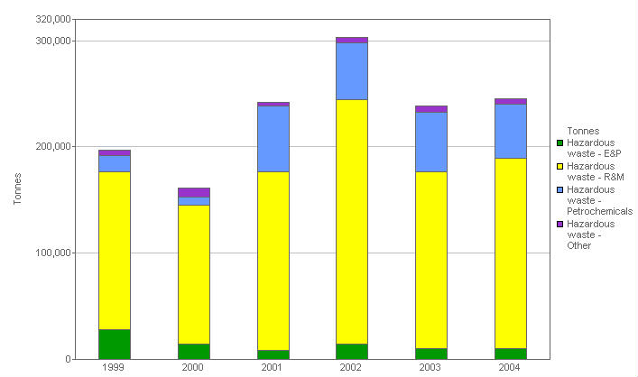

**Total hazardous waste: By business segment. This stacked bar chart shows the total hazardous waste, analyzed by business segment.**

1. Find two data visualizations that you think are good data visualizations (they don’t have to be perfect, just good). Identify what the main message the creator is trying to communicate and describe three aspects of the figure that you think the figure does well. Use the points from this lecture to support your case. Be sure to include the original source of the figure (source organization or publication and a link).
   1. Good data visualization 1 [3 points]
   2. Good data visualization 2 [3 points]
2. Find two data visualizations that you think are bad data visualizations. Identify what the main message the creator is trying to communicate and describe three aspects of the figure that you think the figure does poorly. Identify what might be improved. Use the points from this lecture to support your case. Be sure to include the original source of the figure (source organization or publication and a link).
   1. Bad data visualization 1 [3 points]
   2. Bad data visualization 2 [3 points]